|  |  |
| --- | --- |
| **Name** | **Muhammad Ashab Rahman** |
| **Roll NO** | **2021-cs-666** |
| **Submitted to:** | **Sir Waqas Ali.** |

**Task No 1:**

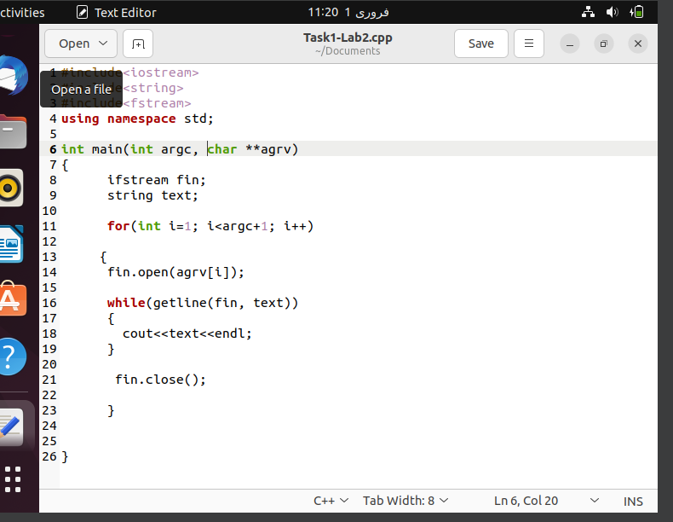

Output:

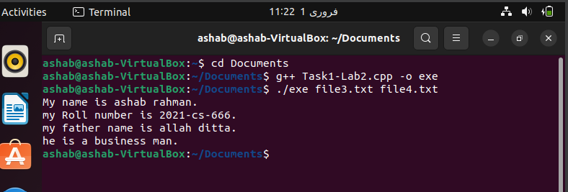

**Task3:**

1. Create a file named “19f-XXXX.txt”. File must contain at least 10 lines.

2. Create another file named “your name.txt”. File must contain at least 10 lines.

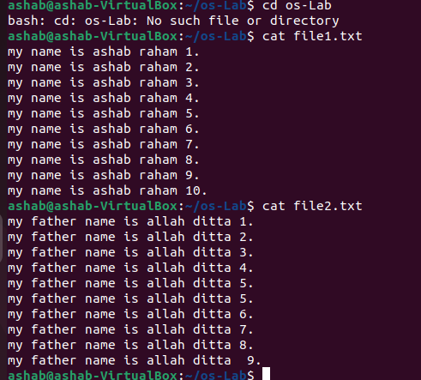

3. Merge the data of both files.

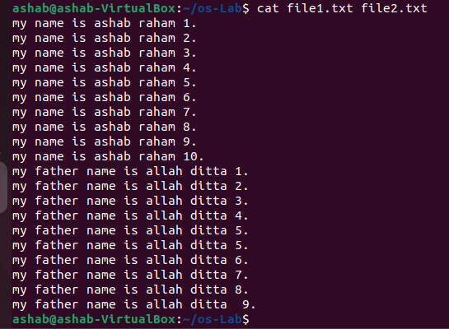

5. Display the first two lines of the first file.

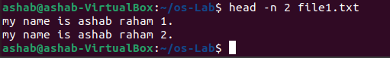

6. Display the last two lines of the second file.

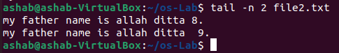

7. Finds the string (your roll#) from the first file.

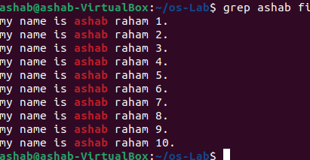4

8. Grant the execute permission of the second file to the group.

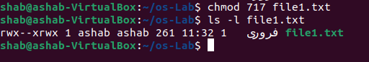

9. Remove the write permission for the owner.

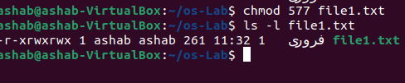

10.Now Mr. Tom suddenly lost track of his current location. Help him find his

location.



11.He wants the list of all files present in the Desktop directory.



12.Now he wanted to create a folder of his personal files and pictures named as

your roll#.

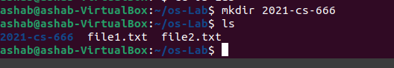

13.Display the current time.

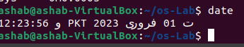

14.He is done with the task and he is happy with your work. He want to display a

thankyou message.



***Task 4:***

1. Create a file named “19f-XXXX_OS-lab_rules.txt” using linux commands.

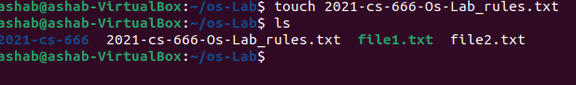

2. You want to set the rights of the created file to this (- rwx r-x r--). For these

rights, you are required to convert the given rights in numeric format using

binary number system procedure covered in lecture. Show complete working.

**(- rwx r-x r--)**

**For Owner : rwx = 7 | Binary number = 111**

**For group : r-x = 5 | Binary number = 101**

**For Other users : r-- = 4 | Bianry number = 100**

3. Now use the derived number to change the permission of a file using the chmod command.

